Birla Institute of Technology & Science, Pilani
Work-Integrated Learning Programmes Division
First Semester 2017-2018
Mid-Semester Test
(EC-2 Regular)

Course No. : SS ZG526
Course Title : DISTRIBUTING COMPUTING
Nature of Exam : Closed Book
Weightage : 30%
Duration : 2 Hours
Date of Exam : 23/09/2017 (AN)
No of pages: 2
No of questions: 5
Note:
- Please follow all the Instructions to Candidates given on the cover page of the answer book.
- All parts of a question should be answered consecutively. Each answer should start from a fresh page.
- Assumptions made if any, should be stated clearly at the beginning of your answer.

Q1.a) Discuss the 4 different features of distributed systems. [4]
Ans:
1. No common physical clock
Introduces “distribution” element into the system
Gives rise to asynchrony amongst processors

2. No shared memory
Absence of common physical clock
Requires message passing for communication
Abstraction of common address space may be provided via distributed shared memory abstraction

3. Geographical seperation
Processors are geographically wide apart
Processors may reside on a WAN
Processors on a LAN – small distributed system
Network/Cluster of Workstations (NOW/COW) configuration – processors connected on a LAN
Popularity of NOW – emergence of low-cost high-speed off-the-shelf processors
Google search engine - based on NOW architecture

4. Autonomy and Heterogeneity
Loosely coupled processors
Different processor speeds
Different operating systems
Processors are not part of a dedicated system
Cooperate with one another
May offer services
May solve a problem jointly

Q1.b) Describe the causal ordering model of communication. [1]
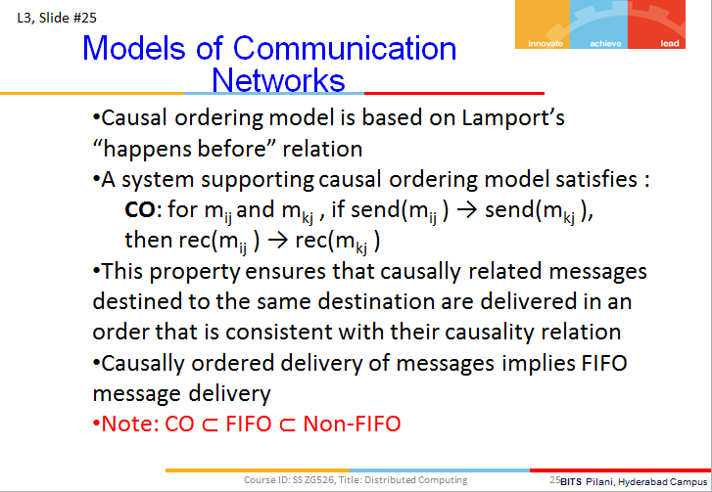

Q1.c) Define cut of a distributed computation. [1]
Ans:
From slides of L3:
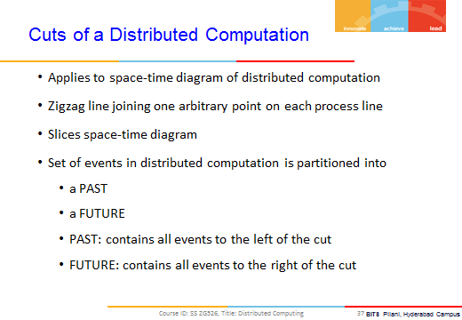

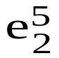
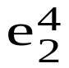
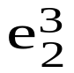
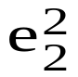
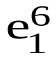
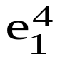
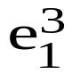
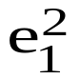
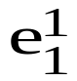
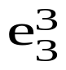
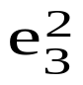
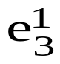
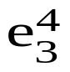
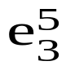
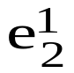
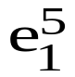
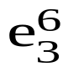
Q2.a) Consider the space-time diagram shown in Fig. 1 depicting 3 processes.
Fig. 1
p₁
p₂
p₃
Time
Processes

Are the following pairs of events causally related? Justify your answer. [1 x 4 = 4]
(i) 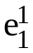 and 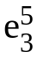 (ii) 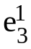 and 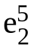 (iii) 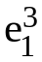 and 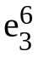 (iv)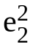 and 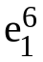

Q2.b) For the space-time diagram of Fig. 1, is the global state 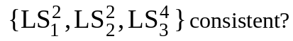 Give reasons in support of your answer. [1]
Ans: L3-P2

Q3.a) Identify the scalar clock values of the events and the timestamps of the messages exchanged among the 3 processes shown in Fig. 1. Initially, the scalar clocks of all the 3 processes are 0. Use R1 and R2 for updating the scalar clocks. Assume d = 1. [4]
Ans:
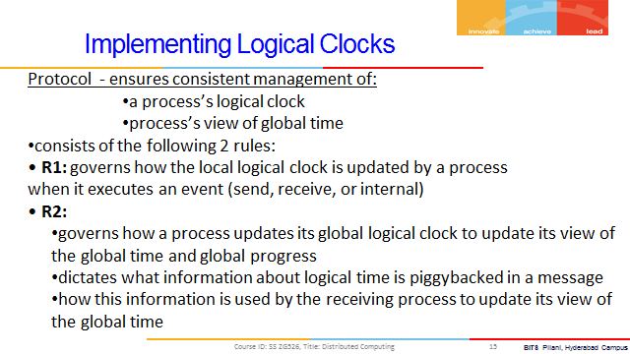
…
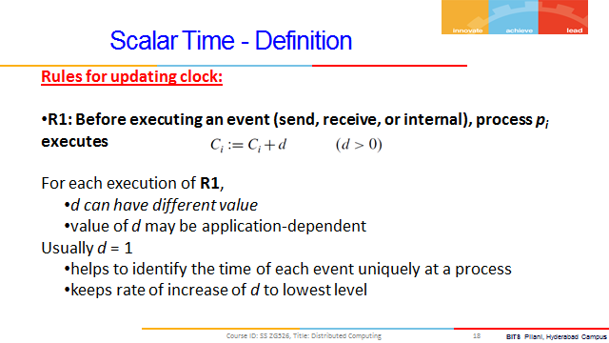
…
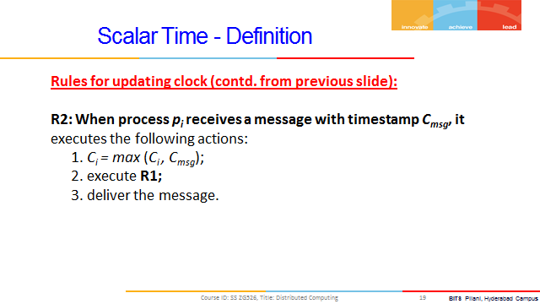
…
Example:
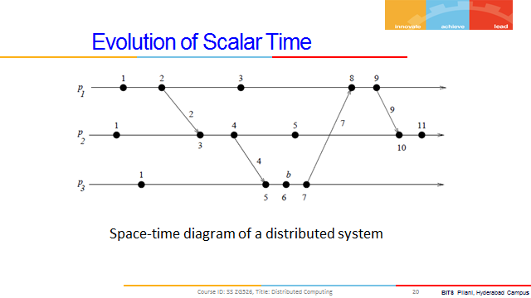
…
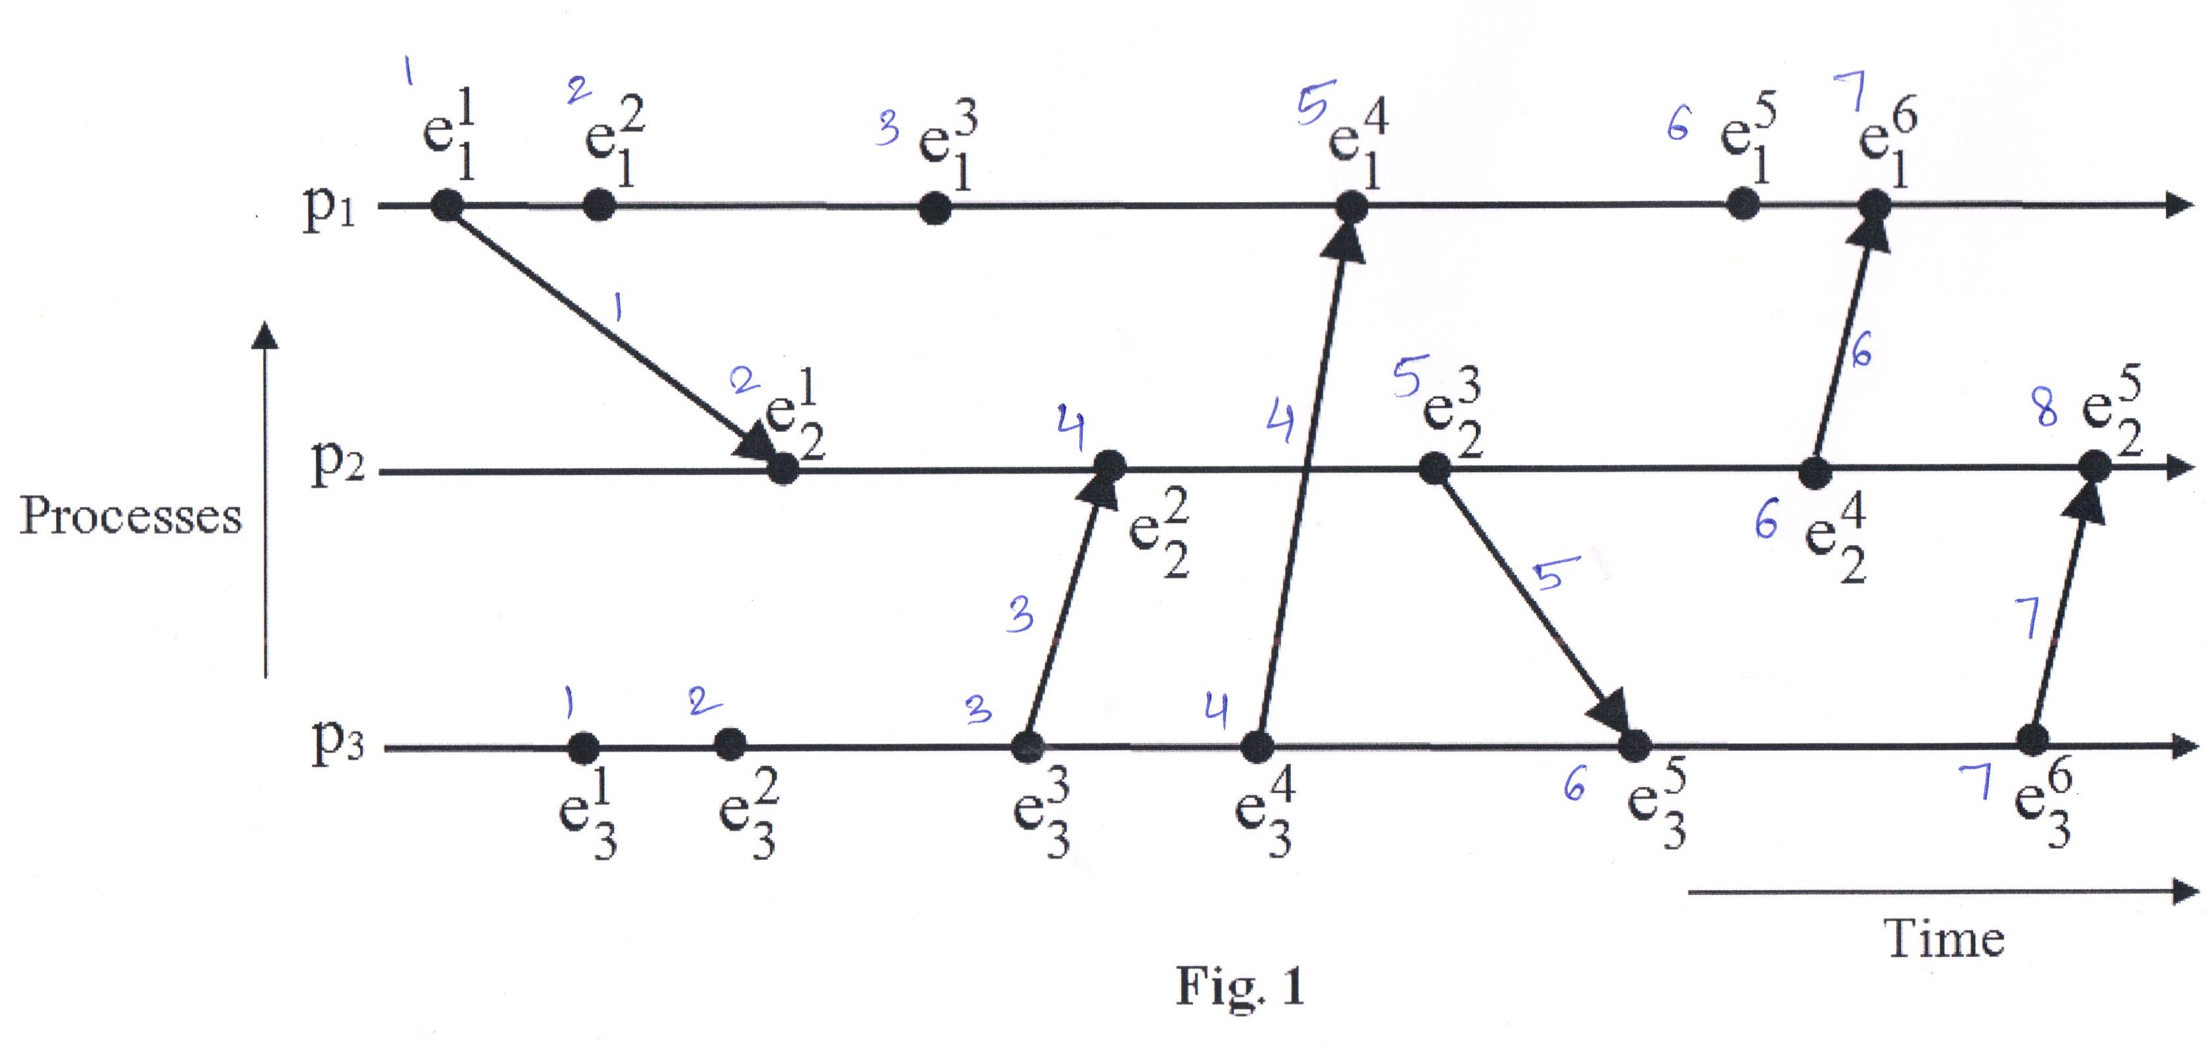
…
Q3.b) What are the heights of events 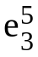 and 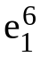 in Fig. 1? [½ + ½ = 1]
Ans:
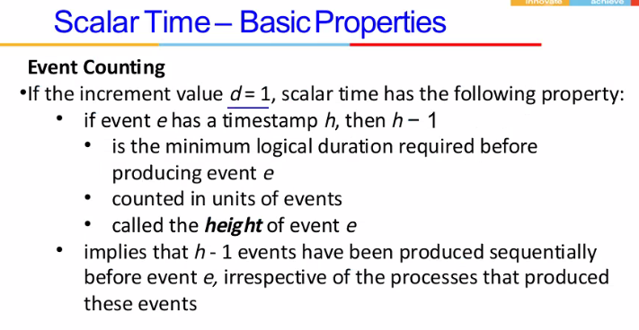
…

Q3.c) Is the expression (e_{x} || e_{y}) ∧ (e_{y} || e_{z}) ⇒ e_{x} || e_{z} correct for any 3 events e_{x}, e_{y} and e_{z}? Explain your answer. [1]

Q4.a) Write a short note on Butterfly network by clearly describing the interconnection function and the routing function. Note that your answer should be accompanied with a diagram illustrating the interconnection pattern for an 8-input and 8-output Butterfly network. [2 + 2 = 4]
Q4.b) What are the 2 conditions that must be satisfied by a global state so that we can say that it is a consistent global state? [2]
Ans:
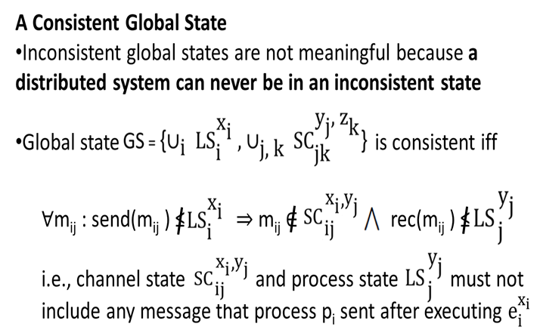

Q5.a) Determine a BFS spanning tree by applying the synchronous single-initiator spanning tree algorithm using flooding on the graph shown in Fig. 2. Assume node A to be the root node. Clearly show the round numbers in which the QUERY messages are sent by the different nodes. [5]

F
B
D
A
C
E
Fig. 2
G

Ans 5.a.)
Synchronous Single-Initiator Spanning Tree Algorithm using Flooding
Local Variables maintained at each P_{i}
  - int visited
  - int depth
  - int parent
  - set of int Neighbors
Messages exchanged between processes
  - QUERY
…
Initially at each P_{i}
  - visited = 0
  - depth = 0
  - parent = NULL
  - Neighbors = set of neighbors

Algorithm for P_{i}
Round r = 1
if P_{i} = root then
visited = 1
depth = 0
send QUERY to Neighbors
if P_{i} receives a QUERY message then
visited = 1
depth = r
parent = root
plan to send QUERYs to Neighbors at next round

Algorithm for P_{i}
Round r > 1 and r <= diameter
if P_{i} planned to send in previous round then
P_{i} sends QUERY to Neighbors
if visited = 0 then
if P_{i} receives QUERY messages then
visited = 1
depth = r
parent = any randomly selected node from which QUERY was received
plan to send QUERY to Neighbors \ {senders of QUERYs received in r}

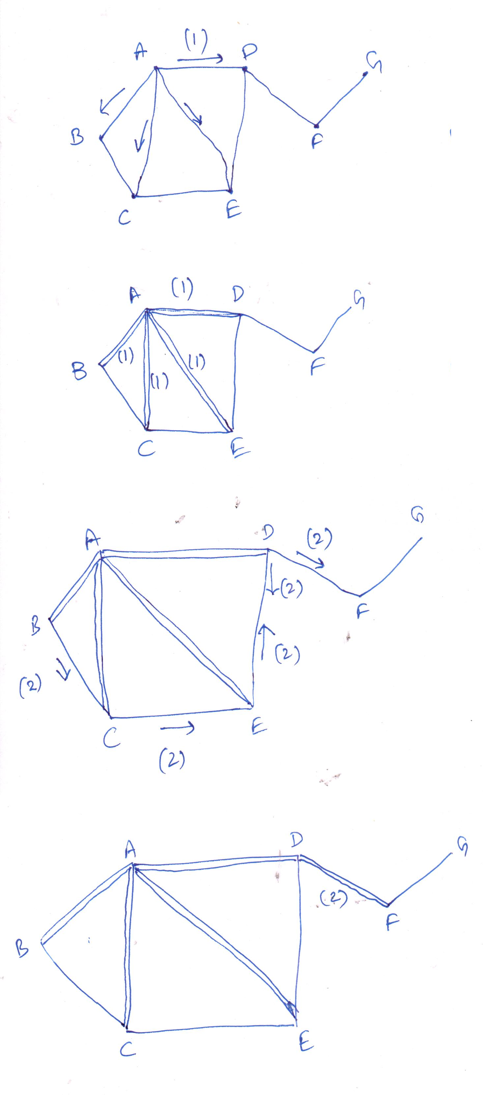
…
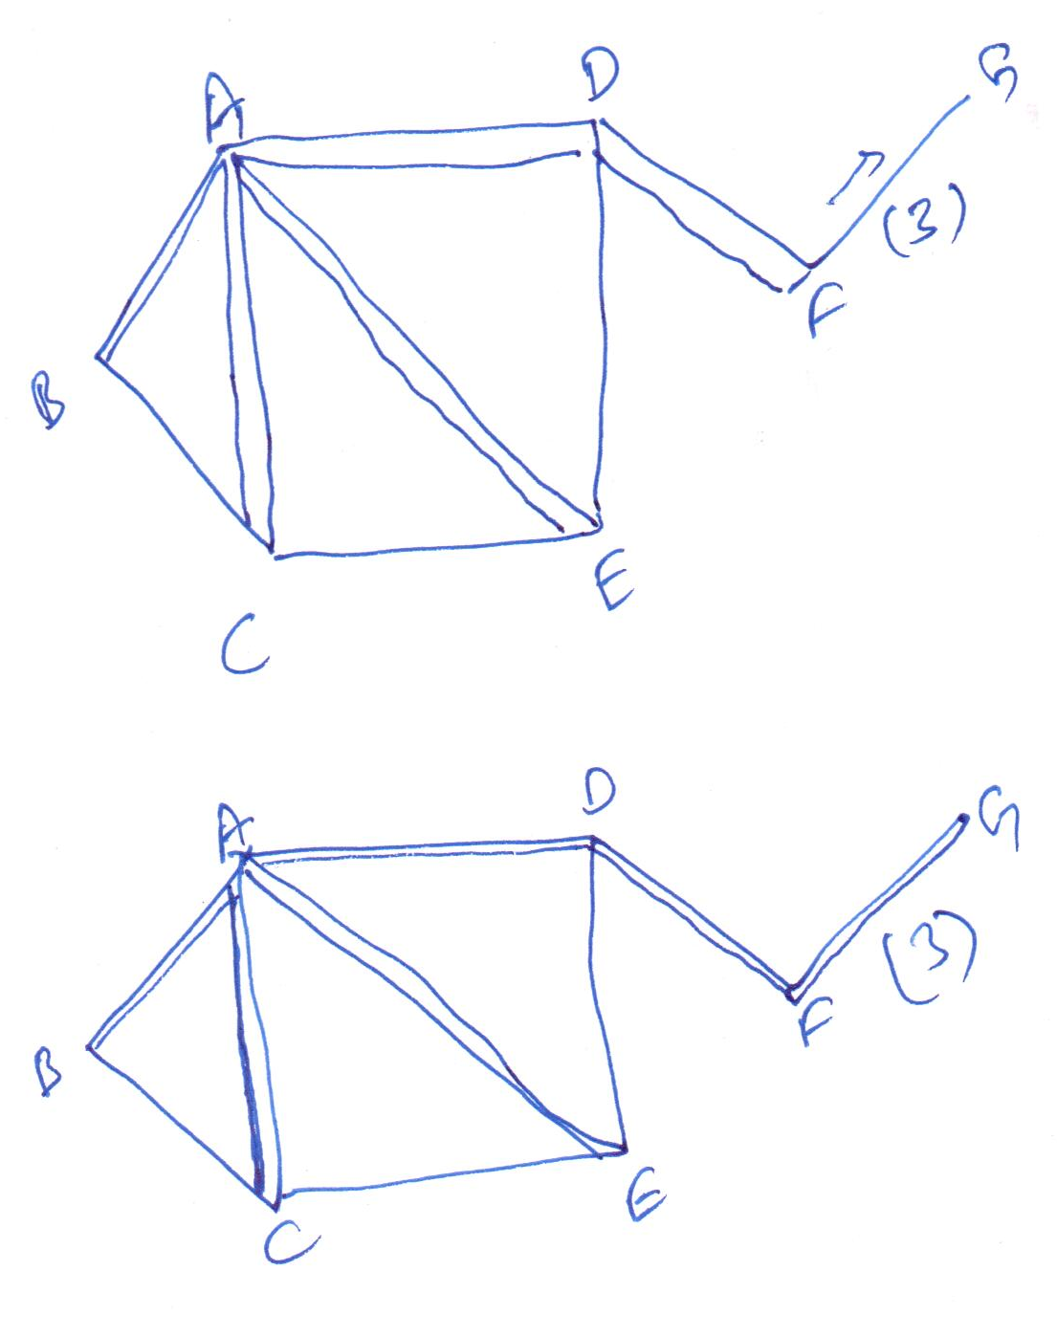
Q5.b) Describe the different steps of the Birman-Schiper-Stephenson Protocol. [2]

**********

